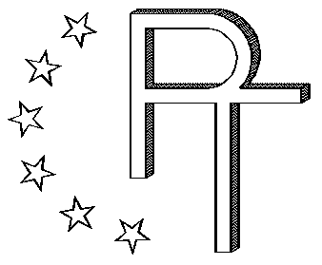

PROGE-TEC S.r.l.

AUTOMATIC LIPPING MACHINE PROGE51
patented system

illustrated catalog

REGISTERED OFFICE:
23 GenoVa street – 20010 PREGNANA Milanese (mi) – ITALY
Operational center:
1 montecassino STREET – 20021 baranzate di bollate (mi)
italy – tel. +39.02.38203233 – fax +39.02.38203803
E_MAIL: info@proge-tec.com
www.proge-tec.com
The EC PROGE51 certified lipping machine is normally used in saucepan production lines, particularly where automatic deformation of the pot or pan is required (e.g. lipping of milk pots, conical casseroles, etc..) after it has been pressed out. It is configured as a highly versatile machine tool, simple to use and built to guarantee high production rates.

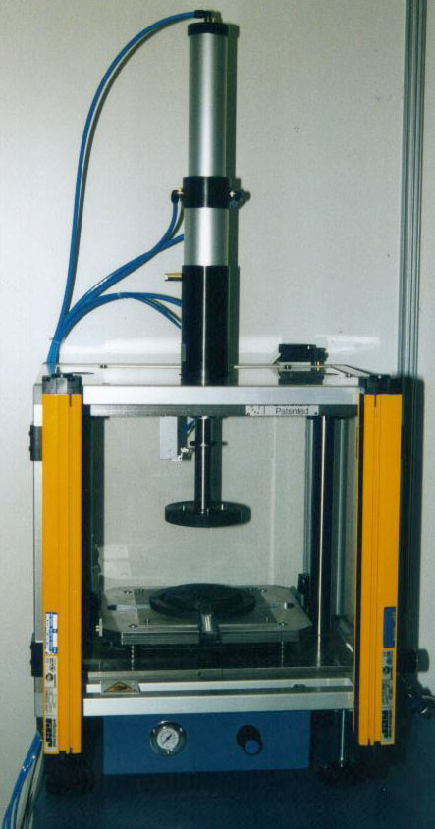

The structure of the machine, particularly with its guards and safety device, makes the PROGE51 safe and inaccessible to the operator during its work cycle.
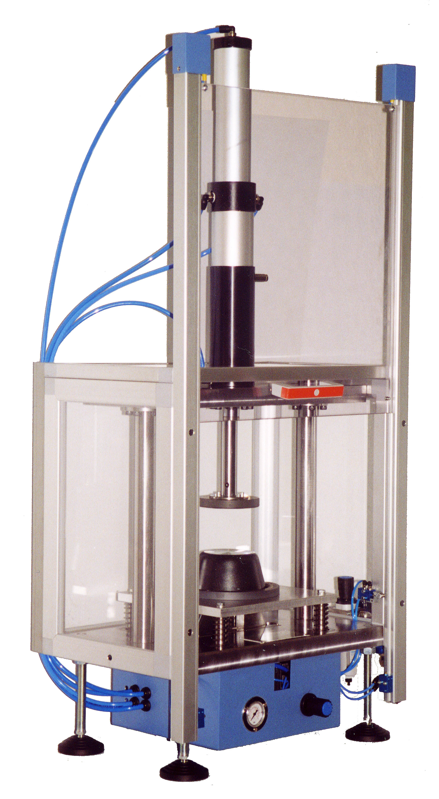

The type of deformation required by the customer and type of part to be deformed determines the deforming tools to be used.
The system enables the use of one or more tools without the need for any changeover.

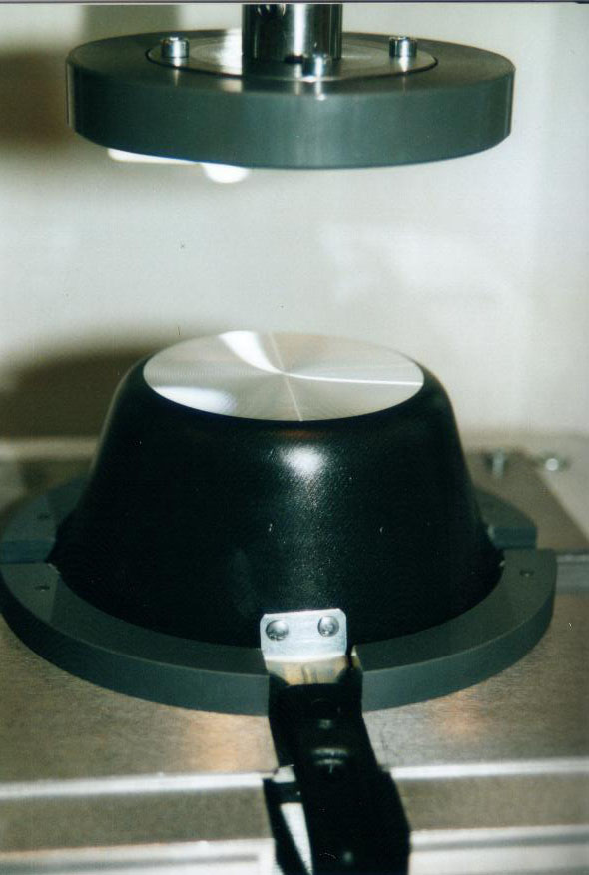

The deforming tools may have different shapes and angles according to the lip, which is to be obtained from the operation.

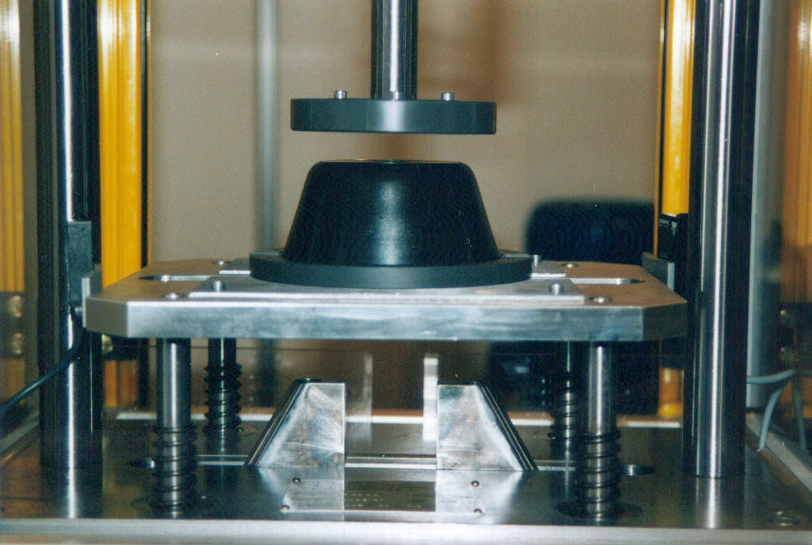

The pot or pan is deformed by pressure of the same against the deforming tools, and the force exerted by the pressing head determines the deformation depth. The pressing force is adjusted simply by turning a knob.

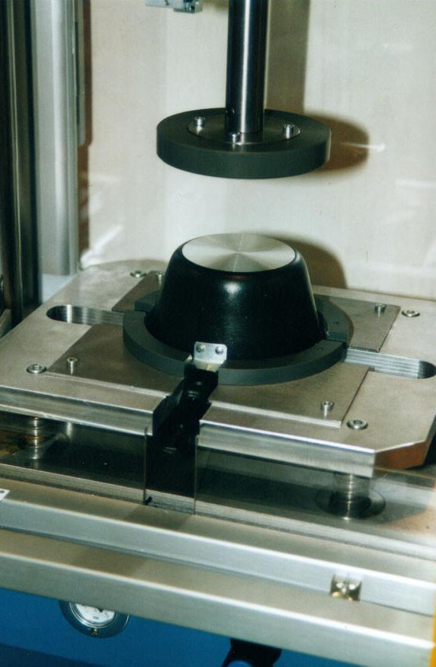

The special shape of the machine allows high flexibility and facilitates retooling: having decided on the type of tool to be used, it is possible to change from one article to another merely by replacing the part containing template.

TECHNICAL FEATURES *

Max. external diameter of article to be deformed
(standard version of the machine): 295 mm.

Max. height of article to be deformed
(standard version of the machine): 250 mm.

Work cycle time: 1 sec. approx.

Max or standard work approach stroke: 85mm. + 30 mm.

Standard work force (min.): 330 kg a 2 BAR

Standard work force (max.): 1000 kg a 6 BAR ca.

Standard approach force (min.): 40 kg a 2 BAR

Standard approach force (max.): 120 kg a 6 BAR ca.

Overall weight: 100 kg approx.

Machine body dimensions: 660x400x1350 mm.

* Rights to make changes reserved

