RIVETING MACHINE PROGE11

The continuous activity of research and development of PROGE-TEC S.r.l., enabled us to present on the world market the new automatic riveting machine PROGE11.
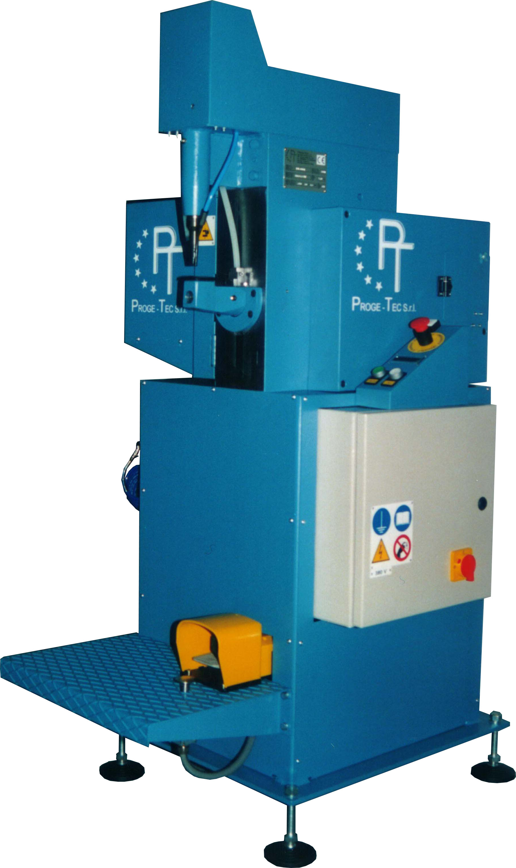

The innovative PROGE11 is a competitive riveting machine with reduced overall dimensions.
It has been designed and produced for the riveting of handles to pots and pans having a medium-low thickness using rivets diam. 3,5 or 4 mm. in aluminium and aluminium alloys.

This machine has completely been realised with high quality items and trade brand components, thus giving assurance of reliably in time.

The use of new technologies of control, processing and synchronization of the electromechanical devices make this machine unique in this market. In fact any operator can easily use, even without a skilled experience.

Appropriate protections and safety devices on the machine warrant the health and safety of the operator in his work place. The riveting machine PROGE11 fully complies with current EC standards regarding health and safety.
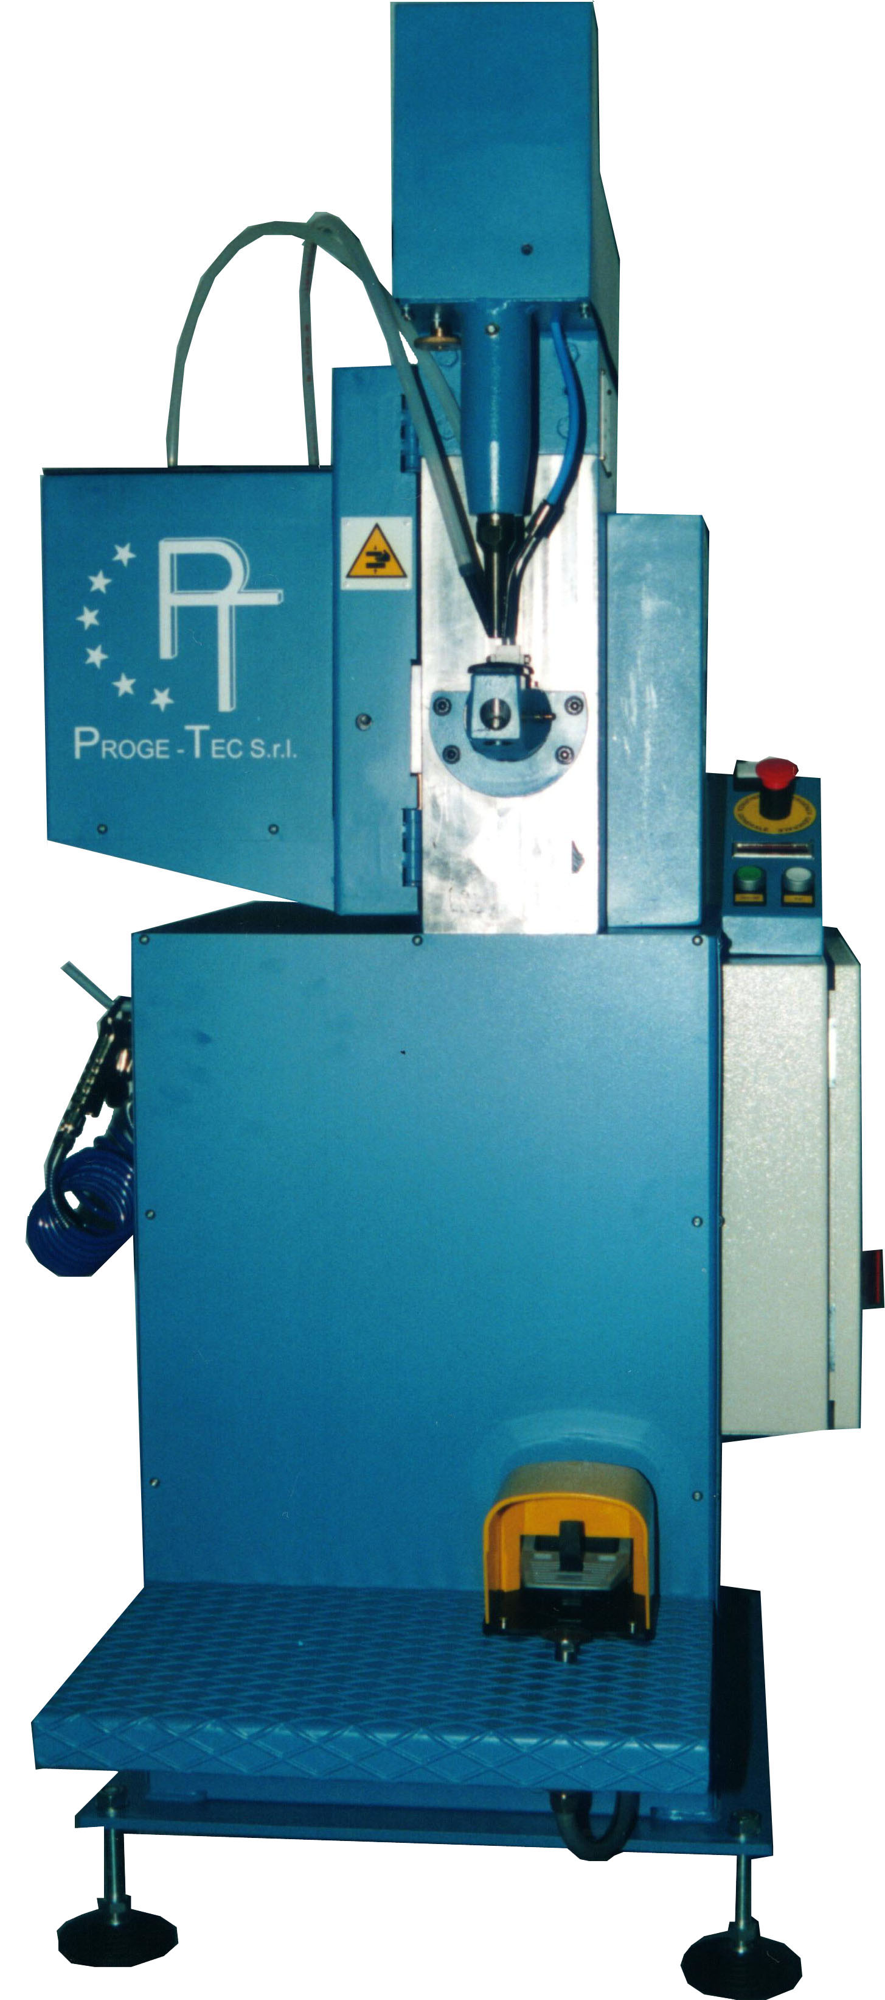
*** PATENTED ***

TECHNICAL DATA

Rivet diameter 3,5 mm – 4 mm

Min. rivet length 7 mm – 8 mm

Max. rivet length 12 mm – 12 mm

Material of the rivet Al alloy

Max. pierceable thickness in aluminium 3 mm around

Standard cycle time 0,70 sec. around

Min. diameter of the item to be riveted (standard) 65 mm around

Power supply 380 V +N

Max. absorbed power 2,5 KW

Compressed air supply pressure 6 bar

Dimensions 700x1000x1500 mm

Net weight 250 Kg. around


PROGE-TEC Srl

Via Montecassino, 1 – 20021 Baranzate di Bollate (MI)
sede legale: Via Genova, 23 – 20010 Pregnana Milanese (MI)
Tel.: ++39.02.38203233 - Fax.: ++39.02.38203803
e-mail: info@proge-tec.com
www.proge-tec.com

