

PROGE-TEC S.r.l.

AUTOMATIC RIVETING MACHINE PROGE01

illustrated catalog

REGISTERED OFFICE:
23 GenoVa street – 20010 PREGNANA Milanese (mi) – ITALY
Operational center:
1 montecassino STREET – 20021 baranzate di bollate (mi)
italy – tel. +39.02.38203233 – fax +39.02.38203803
E_MAIL: info@proge-tec.com
www.proge-tec.com
The PROGE01 riveting machine sets a new standard of quality in the market for its power, reliability, remarkable quietness and ease of use.

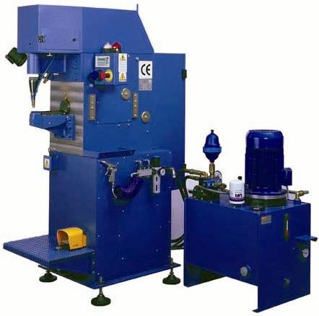

The reduced number of parts make the machine very easy and cheap to maintain.

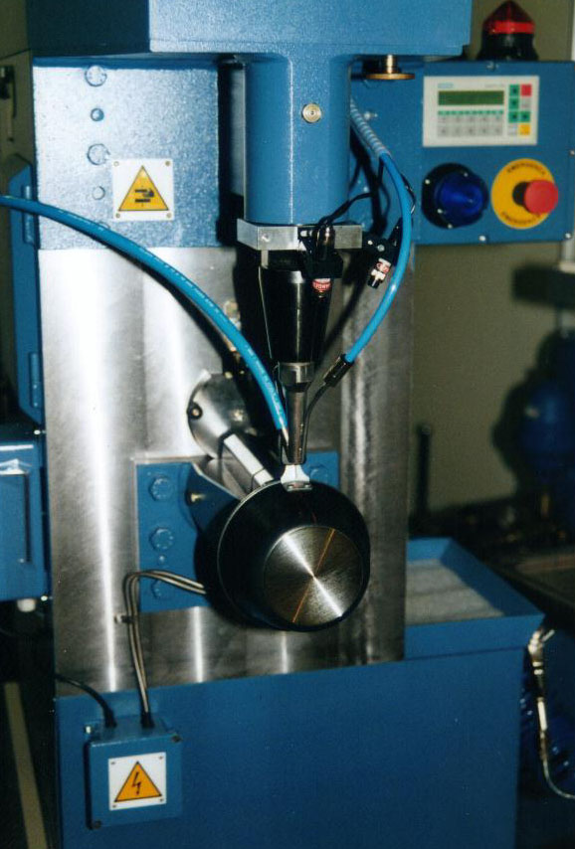

PROGE01 is a power riveting machine for riveting handles onto cookware shells with rivets ranging from Ø 3 mm to Ø 8 mm in soft and hard aluminium alloy, or from Ø 3 mm a Ø 6 mm in AISI 304 steel.

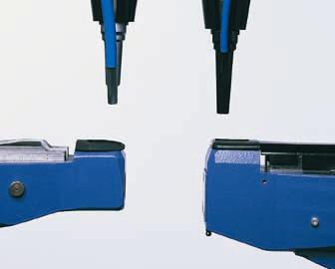
The machine is operated hydraulically and pneumatically, which makes the machine:
- easy to operate,
- easy to reconfigure when passing from one diameter rivet to another,
- easy to set up and maintain,
- easy to control from the main panel,
- highly flexible when producing lots of multiple sizes in a single shift.

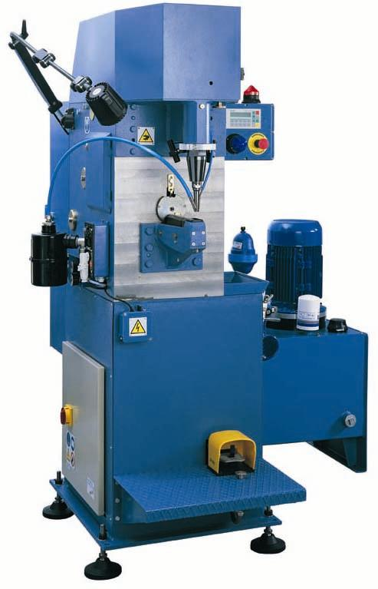
All machine functions are controlled electronically by means of a Siemens series S7 PLC. Simple keyboard operations carried out on the control panel allow the operator to determine cycle times and execute different operating programmes.

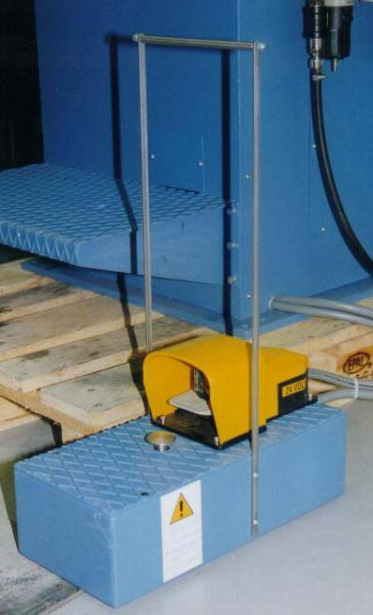

All hydraulic and pneumatic cylinders are directly controlled from the main panel to allow any machine regulations or fine tuning.

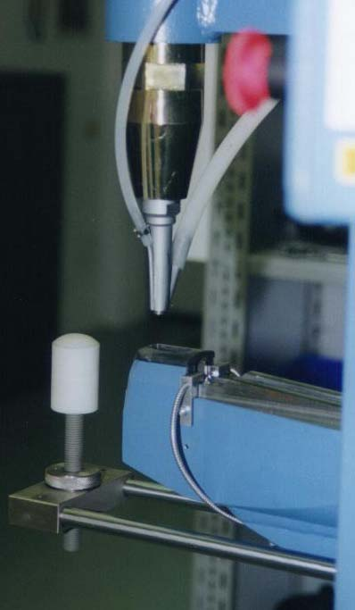

The machine fully complies with current CE standards regarding health and safety, particularly with respect to noise levels.

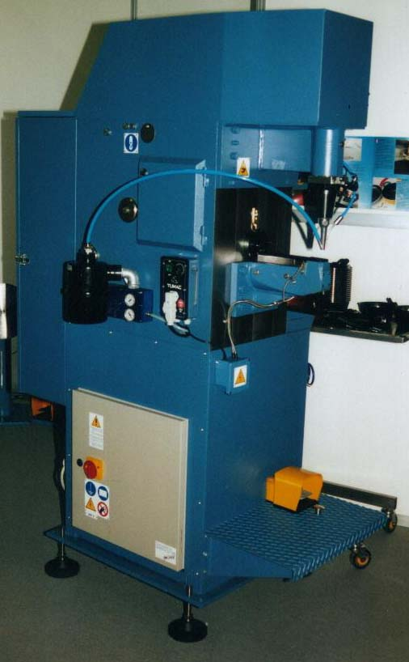

TECHNICAL SPECIFICATIONS *

Cold forming force max 45.000 N.
Blank-holder force max 10.000 N.
Blank-holder counter-pressure max 250 bar
Piercing force max 20.000 N.
Max. rivet diameter Ø 8 mm.
Min. rivet diameter Ø 3 mm.
Max. rivet length 30 mm. (theoretical)
Min. rivet length 7 mm.
Max. pierceable gauge of alum. 10 mm. (theoretical)
Max. total rivetable gauge (Al) 26 mm. (theoretical)
Standard duration of work cycle 1,20 sec.
Min. duration of work cycle 0,97 sec.
Standard depth of beak-iron 250 mm.
Max. stroke of standard hammer 25 mm.
Max. stroke of stand. blank-holder 30 mm.
Max. stroke of standard punch 30 mm.
Max. pressure of hydraulic piercing cylinder 100 bar.
Max. pressure of hydraulic blank-holder cylinder 80 bar.
Max. pressure of hydraulic cold-forming cylinder 145 bar.
Power supply 380 V 7,5 kW 25 A
Compressed air required 6 bar
Background noise level 30 db (A)
Noise level in stand-by 65 db (A)
Working noise level 74 db (A)
Net weight (without hydraulic oil) 980 Kg.

